Welcome to our practice!
Please help us serve you better by taking a few minutes to provide the following information.
Contact Information
Name: |  |  |  | Today’s date:
Address:
City / State / ZIP:
Phone # | MOBILE | HOME |  |  | WORK
DOB: |  |  | Age: |  | Marital status: |  | ☐M | ☐S | ☐W | ☐D
Email:
Occupation: |  |  | Employer:
Emergency Contact |  |  | Phone:
Primary Care Physician |  |  | Date of next visit
Specialist Physician |  |  | Date of next visit

How did you hear about our practice?
Who can we thank for referring you to our practice?

Please fill out these forms as specifically as possible to provide us with a clear picture of your present pain and functional status.
Reason for your Visit
What is the primary issue/problem that brings you in today? | Please shade in areas where you have pain, discomfort, or tension.  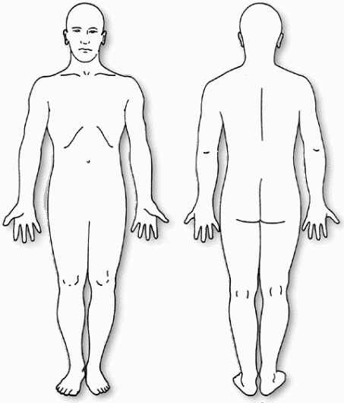
Secondary concern/problem?
As a result, I am now having difficulty with:
Are you currently experiencing pain as a result of these symptoms? If yes, what is it like?
When did your symptom(s) begin? (Date):

Describe your pain
Rate your pain in the last 24-72 hours. Please, use the “0 -10” scale where 0 is no pain and 10 is the worst possible pain. | At its worst
 | At its best
 | At present
At what time of day are your symptoms the worst?
At what time of day are your symptoms the best?
What activities increase your pain?
What activities decrease your pain?

What other types of treatment have you had for this problem?
☐Massage | ☐Acupuncture |  | ☐Physical Therapy | ☐Injections | ☐Chiropractic | ☐Surgery
☐Other Medical Treatment:
(Please Describe)

Check the box if you have had any of the following medical conditions?
☐  Diabetes | ☐  Lung disease | ☐  Weight change | ☐  Varicose veins | ☐  Neurological problems | ☐  Infectious Disease
☐  Rheumatic fever | ☐  Osteoporosis | ☐  Migraine headaches | ☐  Epilepsy / seizures | ☐  Stroke | ☐  Blackouts
☐  Heart Murmur | ☐  Cancer | ☐  Arthritis | ☐  Broken bones (fracture) | ☐  Metal implants | ☐  High blood pressure
☐  Circulatory problems | ☐  Liver disease | ☐  Heart disease / pacemaker | ☐  Kidney disease | ☐  Others (explain below)

List past medical history and dates of occurrence. Include surgeries, accidents and other traumas.

List ALL medications which you are currently taking, the condition for which you are using them, the dose, and their effectiveness. (Include supplements, herbal and homeopathic remedies).
Medication | For treatment of | Dose / Amount per day | Effectiveness

Do you smoke? | Yes | No | If “Yes” – How much?
When did you quit? |  |  | If not, Would you like to quit?

Is there a chance you may be pregnant at this time? | Yes | No

Do you engage in regular exercise? |  | Yes | No
What type and how often?
Are you able to exercise now? |  | Yes | No

Do you have discomfort, shortness of breath, or pain with exercise? |  |  |  |  | Yes |  | No
Please Describe:
In general, your lifestyle is: | 1 | 2 | 3 | 4 |  | 5
 | Active |  | Average |  |  | Inactive
If sleep is a problem, answer these questions:
Do you have trouble falling asleep? | Yes | No | Do you find it difficult to change positions in bed?
Is your sleep restful? | Yes | No | How many times do you wake in the night?
Do you find it difficult to lie down? | Yes | No | How long before you fall back to sleep?

List all the Tasks / Activities that you have difficulty performing and your tolerance (minutes/hours).
If you are no longer able to perform an activity, your tolerance would be “0”.
Task / Activity | Tolerance (minutes/hours)

I walk for |  | minutes before needing to rest
I stand for |  | minutes before needing to sit
I sit for |  | minutes before needing to change positions/get up
Do you have trouble getting up from a chair? |  |  | Yes | No
Do you have trouble putting on your shoes and socks? |  |  | Yes | No
Do you have difficulty climbing stairs? |  |  | Yes | No
Patient Goals
Please list the activities that you would like to be able to do as a result of therapy.
Task / Activity | Duration / How Often | By When
Other Goals?

Informed Consent

I understand that Molina Physical Therapy will maintain my privacy to the highest standards and may use or disclose my personal health information for the purposes of carrying out treatment, obtaining payment, evaluating the quality of services provided and any administrative operations related to treatment or payment.

Patients/Clients frequently request that we communicate with them by phone, voicemail, email or text. Molina Physical Therapy respects your right to confidential communications about your protected health information (PHI) as well as your right to direct how those communications occur. Since email and texting can be inherently insecure as a method of communication, we will only communicate with you by email or text with your written consent at the email address or phone number you provide to us below. Please be aware that if you have an email account through your employer, your employer may have access to your email. When you consent to communicating with us by email or text you are consenting to email and texting communications that may not be encrypted. As well voicemail or answering machine messages may be intercepted by others. Therefore, you are agreeing to accept the risk that your protected health information may be intercepted by persons not authorized to receive such information when you consent to communicating with us through phone, voicemail, email or text. Molina Physical Therapy will not be responsible for any privacy or security breaches that may occur through voicemail, email or text communications that you have consented to.

You may choose to limit the type of voicemail, email or text communication you have with us if you wish to limit your risk of exposing your protected health information to unauthorized persons.
Please indicate below what types of correspondence you consent to receive by email or text.
I do not consent to any voicemail, email or texting communication.
I consent to receiving communication about the scheduling of appointments or other communications that do not reveal my protected health information only by the following means (check all that you consent to):
o Email
o Text
o Voicemail
I consent to all communication, including but not limited to communication about my medical condition and advice from my health care providers by the following means (check all that you consent to):
o Email
o Text
o Voicemail
E-mail address you are consenting to communicate through: ___________________________________
Phone number you are consenting to communicate through:___________________________________

Photographs taken during initial evaluation, progress evaluation and discharge summary will be used for postural comparison purposes and as educational tools. By signing below I consent to the use of these photographs in a professional manner.

I do hereby agree and give my consent for Molina Physical Therapy to furnish care and treatment that is considered necessary and proper in the diagnosing or treating of my physical condition.

I understand that I retain the right to revoke this consent by notifying the practice in writing at any time.
I hereby certify that all the above information is true to the best of my knowledge.

Patient/Parent/Guardian Signature:__________________________Date:_________________

Cancellation and No Show Policy

All cancellations need to be made 24 hours prior to your appointment.
If you do not show up for your appointment or cancel with-in 24 hours, you will be responsible to pay for 100% of the session. If we can re-schedule your appointment, you will not be charged for a cancellation.

Payment Policy

We are not contracted with any insurance companies. However, the payments you make may be reimbursable by your insurance company under your out of network physical therapy benefits; the exact percentage depends upon your plan. Due to the complex nature of insurance claims and reimbursement, I make no promises as to whether you will receive reimbursement.

We will assist you in every way possible. Payment is due at the time of service.

I have read and understand the above policies:

Name_____________________________________

Signature__________________________________ Date_______________

Thank you for your cooperation and business.

Cindy Molina PT
Molina Physical Therapy, LLC

